Order Of Service

Singing: Psalm 34—CW page 80

Reading: Psalm 78:21-31

Opening Hymn: CW 256

Reading: Acts 11:19-30

Request Hymn: CW Supplement 748

Reading: John 20:24-31

Sermon Hymn: CW 363

Sermon Text: Daniel 6:19-24

Daniel Saved

Prayer

The Apostles’ Creed, TLH page 12

Holy Communion

The Lord's Prayer

The Blessing

Closing Hymn: CW 449

* * * * * * * * * * *

Koinonia Hour

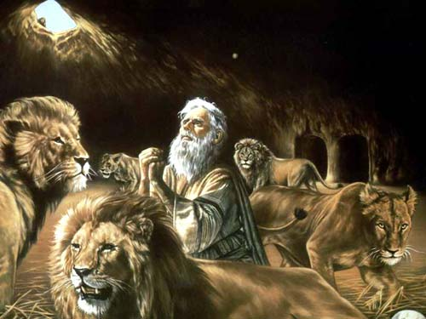

Daniel Saved

Water
Of
Life

1 July 2018

W A T E R O F L I F E

Independent Christian Church—Conservative Lutheran Doctrine

Worship Service: 9:30 a.m. Bible Study: 10:45 a.m.

Larry Cooper, Pastor E-Mail address:
111 N. Ridge Road lcooper@wateroflife.cc
Coon Valley, WI 54623 Web Site:
Phone: (608) 452-2105 www.wateroflife.cc

* * * * * * * * * * * * * * * * * * * * * * * * * * *

Sermon Text: Daniel 6:19-24

Daniel Saved

* * * * * * * * * * * * * * * * * * * * * * * * * * *

Daniel 6:19 Then the king arose very early in the morning, and went in haste unto the den of lions.
:20 And when he came to the den, he cried with a lamentable voice unto Daniel: and the king spake and said to Daniel, O Daniel, servant of the living God, is thy God, whom thou servest continually, able to deliver thee from the lions?
6:21 Then said Daniel unto the king, O king, live for ever.
:22 My God hath sent his angel, and hath shut the lions' mouths, that they have not hurt me: forasmuch as before him innocency was found in me; and also before thee, O king, have I done no hurt.
:23 Then was the king exceeding glad for him, and commanded that they should take Daniel up out of the den. So Daniel was taken up out of the den, and no manner of hurt was found upon him, because he believed in his God.
:24 And the king commanded, and they brought those men which had accused Daniel, and they cast them into the den of lions, them, their children, and their wives; and the lions had the mastery of them, and brake all their bones in pieces or ever they came at the bottom of the den.

* * * * * * *

Deuteronomy 19:16-21—Related Reading

16 If a false witness rise up against any man to testify against him that which is wrong;
17 Then both the men, between whom the controversy is, shall stand before the LORD, before the priests and the judges, which shall be in those days;
18 And the judges shall make diligent inquisition: and, behold, if the witness be a false witness, and hath testified falsely against his brother;
19 Then shall ye do unto him, as he had thought to have done unto his brother: so shalt thou put the evil away from among you.
20 And those which remain shall hear, and fear, and shall henceforth commit no more any such evil among you.
21 And thine eye shall not pity; but life shall go for life, eye for eye, tooth for tooth, hand for hand, foot for foot.

